**Backups and Recovery**

**Premise**

"I thought I was on my development machine and I’ve accidentally dropped a collection in production."

The backup system captured its most recent backup last night, which is in the /home/ec2-

user/scripts/dump directory, but the system subsequently continued to accumulate new data through

the night. You need to restore your data to the point in time just before the you dropped the collection.

The collection is test.users and the total number of documents prior to the drop was 20,000.

Start the mongo DB using bin->mongod

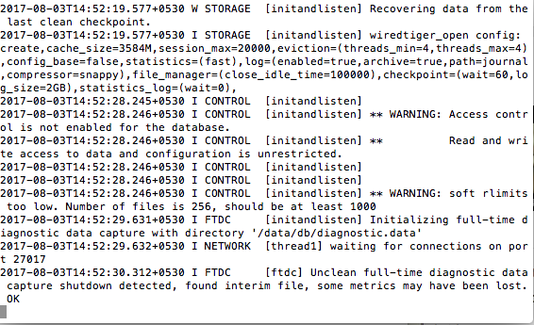

Start the mongo shell using ./mongo like below

Show 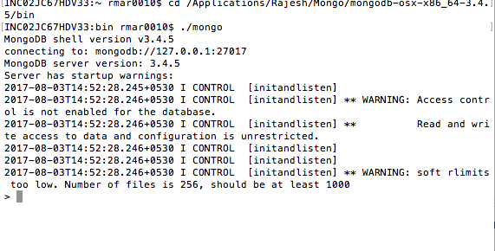

Show databases gives below results

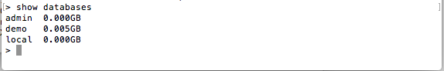

There are some collections in demo database. I am going to use demo.

Now Demo is added a collection called employee having huge data. And the count is shown below.

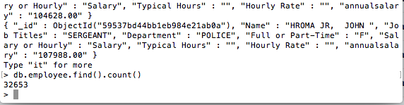

So I am going to navigate to bin directory in one more terminal for mongodump show below.

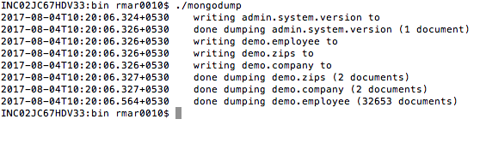

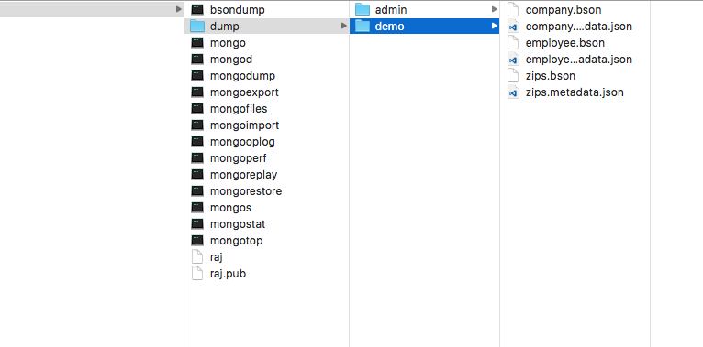

In above screenshots can see the dumped data.

Now I am going to drop the entire DB.

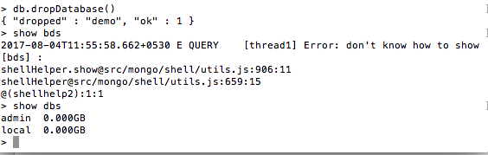

We can see now demo is disappeared. Now I am going to backup entire DB.

I just moved to admin window with bin path and used restore option.

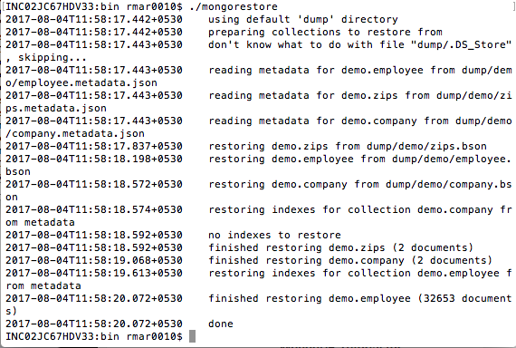

Now I can able to see demo database present

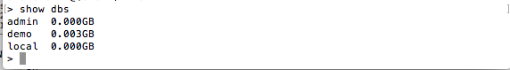

Now I am going to drop the employee collection and restore it as mentioned in problem statement. First I am going to delete the dump folder which already created. Below image shows the list of collection. Out of that I am going to backup and restore employee.

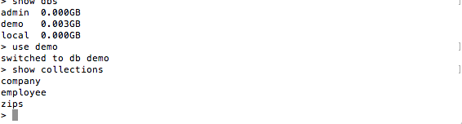

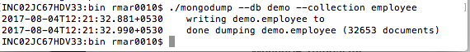

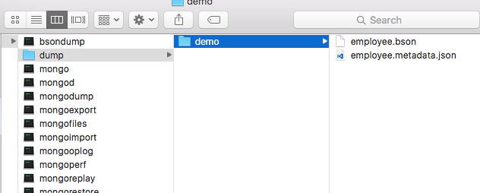

So Collection is dumped in bin directory. Now Its time to restore it.

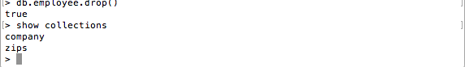

Collection is dropped. Will recover it

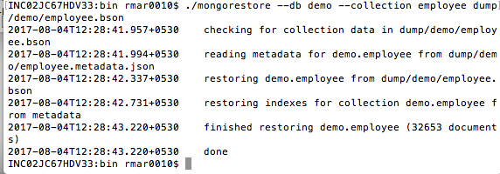

While restoring a collection we need to mention the path like in screenshot.

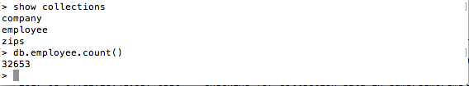

End of backup and restore.